**Sentiment Analysis using BERT Transformer**

**Introduction:**

Navigating the digital landscape, decoding sentiments in text is crucial. This project delves into sentiment analysis, leveraging BERT transformer technology on a dataset from Hugging Face. Beyond emotion classification, our goal is to fill gaps in existing sentiment analysis. With businesses relying on data-driven decisions, our model bridges the gap between raw text and actionable insights.

**Business Relevance:**

Sentiment analysis is vital for diverse business contexts, from assessing customer satisfaction to managing brand reputation. Our model, proficient in decoding nuanced emotions, proves invaluable for businesses extracting actionable insights from textual data. In the era of overwhelming digital opinions, distilling meaningful information from text becomes a competitive advantage.

**Addressing Gaps:**

Our model addresses gaps in sentiment analysis:

1. **Contextual Understanding**: Leveraging BERT's contextual embeddings, our model excels in understanding emotions in context.
2. **Multiclass Classification**: Thriving in multiclass scenarios, it accommodates a diverse range of emotional states, capturing human expression richness.
3. **Robustness**: The model's robustness handles varying sentence lengths and captures intricate semantic relationships, enhancing adaptability to real-world text data.

**Problem Statement:**   
Foundational in natural language processing, sentiment analysis uncovers emotional nuances in text. This project utilizes BERT transformer's capabilities to unveil sentiments in textual data. Sourced from Hugging Face, the dataset propels our journey, not just in model building but in addressing critical gaps in sentiment analysis. As businesses shift to data-driven decisions, sophisticated sentiment analysis models are increasingly essential.

**Data Preprocessing:**

The preprocessing journey embarked upon meticulous checks to ensure data integrity. Instances with multiple emotions or the 'nocode' label were meticulously handled. Employing the BERT tokenizer, text samples underwent tokenization, laying the groundwork for effective model training. The dataset was then stratified, ensuring a balanced representation of emotion classes, a prerequisite for robust sentiment analysis models.

Data Fields

**Model Architecture:**

Driven by the quest for contextual understanding, the BERT transformer architecture emerged as the backbone of our sentiment analysis model. 'BERTForSequenceClassification' from the transformer’s library, infused with 'bert-base-uncased' pre-trained weights, not only shapes our model but sets the stage for decoding emotions with a finesse unparalleled in traditional sentiment analysis models.

*Points of Emphasis:*

* **BERT Transformer:** An embodiment of contextual understanding, pivotal for deciphering nuanced emotions.
* **TensorFlow Framework:** A stalwart in implementing intricate neural network architectures.
* **Hugging Face Datasets:** An invaluable resource streamlining access to curated datasets, propelling our journey into sentiment analysis.

**Tech Stack Used:**

* **Transformers Library:** Seamlessly integrates pre-trained transformer models into our sentiment analysis architecture.
* **TensorFlow:** Chosen for its efficiency in implementing complex neural network architectures.
* **Hugging Face Datasets:** A centralized repository, simplifying the process of acquiring diverse and relevant datasets.

Train-Test-Split data

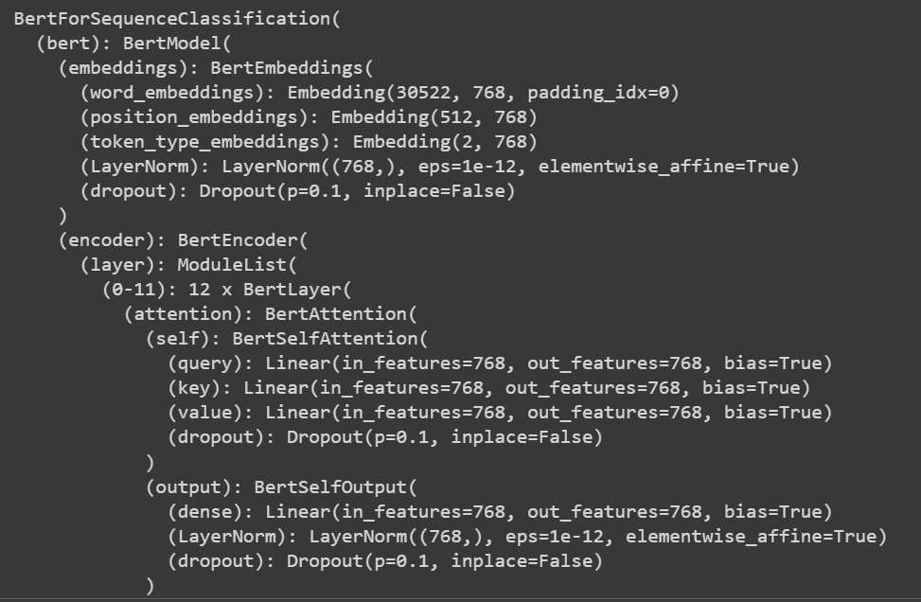

BERT Model Architecture for Sequence Classification

Training Results

**Evaluation Metrics:**

The model's prowess is evaluated through a suite of metrics, providing a holistic understanding of its performance:

1. **Weighted F1 Score:** A nuanced measure, balancing precision and recall across all emotion classes.
2. **Confusion Matrix:** A visual testament to the model's classification acumen.
3. **Accuracy per Class:** Delving into the model's granular accuracy across individual emotion categories.

Confusion Matrix

F1 Score comparison

**Results:**

* The model exhibits commendable prowess after three epochs, boasting a weighted F1 score of [F1 Score Value].
* The confusion matrix provides a visual narrative of the model's proficiency in emotion classification.
* Specific visualizations, such as precision-recall curves or ROC curves, further elucidate the model's discriminative capacity.

Class-wise Accuracy Metrics

**Conclusion:**

The synergy of BERT's contextual understanding, TensorFlow's efficiency, and the rich Hugging Face dataset contributes to the success of our sentiment analysis model. As businesses navigate the dynamic landscape of customer sentiments, our model stands as a reliable ally in decoding the emotional tapestry within textual data.